

Selsted Church of England Primary School

Allergy Safety Policy

Governing Body Ratification Date:
Issue Date: September 2026
Next Review Date: September 2027

Contents
Contents 2
1. Aims 3
2. Legislation and guidance 3
3. Context 3
4. Practical steps (see also Appx I and Appx II) 4
Governors 4
Headteacher 4
Member(s) of Staff responsible for medical needs (Allergy Leads and Administration Staff) 5
All Staff 6
Parents/Carers 6
Pupils with allergies (as age appropriate) 7
5. Supply, storage and care of medication 7
Older children and medication 7
Storage 7
Disposal 8
6. Assessing risk 8
7. Managing risk 8
Hygiene procedures 8
Catering 8
Food restrictions 8
8. Awareness Training 9
9. Allergy Awareness for all 9
10. Allergies and bullying 9
11. Procedures for handling an allergic reaction 10
Register of pupils with AAIs 10
Allergic reaction procedures 10
Allergic Reaction/School Emergency Response 10
Support for mental health 11
Events and school trips 12
12. Adrenaline auto-injectors (AAIs) 12
Purchasing of spare AAIs 12
Storage (of both spare and prescribed AAIs) 12
Maintenance (of spare AAIs) 12
Disposal 13
Use of AAIs off school premises 13
Emergency anaphylaxis kit 13
Records following the use of any AAI device 13
13. Serious Incidents and Near Misses 14
14. Links to other policies 14
Appendix I - First Aid for Anaphylaxis poster 15
Appendix II - Epipen AAI and Jext AAI Instructions 16
Appendix II - Epipen AAI and Jext AAI Instructions 17
Appendix III - Flowchart for Allergic Reaction without use of Adrenaline Auto-Injector 17
Appendix IV - Flowchart for Allergic Reaction with use of Adrenaline Auto-Injector 18
Appendix V - Information on allergies 19
Symptoms 20
Appendix VI - Other support and resources 20
Appendix VII - Top 14 Allergens poster 21

Aims
Selsted CE Primary School are committed to promoting a whole school approach to health care, welfare and wellbeing and the safe management of those members of our school community who live with specific allergies. We believe that all allergies should be taken seriously and dealt with in a professional and appropriate way. By our actions we will work proactively to:
- minimise the risk of exposure within the school setting
- encourage self-responsibility
- learn avoidance strategies
- have robust plans for an effective response to possible emergencies
- ensure inclusivity for all pupils

Legislation and guidance
This policy is based on the Department for Education (DfE)’s guidance on allergies in schools and supporting pupils with medical conditions at school, the Department of Health and Social Care’s guidance on using emergency adrenaline auto-injectors in schools, and the following legislation:
The Food Information Regulations 2014
The Food Information (Amendment) (England) Regulations 2019

Context
Food allergies are increasing in both developed and developing countries, especially in children and the severity and complexity of food allergy is also increasing. Food allergy can be fatal and an appropriate diagnosis is essential in parallel with the need for clear food labelling worldwide.
Around 5-8% of children in the UK live with a food allergy and most school classrooms will have at least one allergic pupil. These young people are at risk of anaphylaxis, a potentially life-threatening reaction which requires an immediate emergency response. 20% of severe allergic reactions to food happen whilst a child is at school and these reactions can occur in children with no prior history of food allergy. It is essential that staff recognise the signs of an allergic reaction, symptoms and are able to manage it safely and effectively.
Schools have a legal duty to support pupils with medical conditions, including allergy.

Practical steps (see also Appx I and Appx II)
In order to put these principles into practice we will:

Governors
- Ensure the school has a strategic vision for the management of allergy risk assessment and emergency procedures
- Delegate the day-to-day responsibility for the effective delivery of this Policy to the Headteacher
- Ensure the school’s arrangements to identify and safeguard the wellbeing of pupils, because of their own or someone else’s allergy, are robust and effective
- Ensure that the school provides appropriate training, information, instruction, induction and supervision on a regular basis to enable everyone to stay safe regarding allergies and their management. It is good practice to log all training and attendees.
- Ensure adequate resources for managing allergies are available
- Ensure appropriate material is available on the school website for parent/carers highlighting how the school is managing pupils/students with allergies
- Monitor the effectiveness of this Policy to ensure it remains fit for purpose

Headteacher
- Provide, as far as practicable, a safe and healthy environment in which people at risk of allergic reaction and anaphylaxis can participate equally in all aspects of school life and are not subject to bullying because of their condition
- Ensure all visitors, volunteers, work experience students, sub-contractors are made aware of the school’s commitment to allergy management as part of Safeguarding
- Ensure the curriculum contains age-appropriate content so all pupils/students can learn about allergies and how everyone can support those who have them
- Create links at a strategic level with Healthcare professionals and Catering providers and ensure at operational level that links are robust
- Ensure that up-to-date allergy information for pupils/students is accessible to catering teams.
- Ensure there is a workable School Emergency Response Plan (see below) in place that is known by all staff
- Ensure the school sends a copy of the medical details it holds for the child to parents/carers for review and update at the end of each school year. Seek updated medical information at the commencement of each calendar year and for any pupil/student joining in year
- Where the pupil/student has an Individual Healthcare Plan (IHP), ensure the involvement of healthcare and welfare professionals, teaching and catering staff, parents/carers and the pupil/ student in establishing IHPs.
- Encourage parents/carers to provide Allergy Action Plans (AAPs) completed and signed by a healthcare professional that can be kept with their medication with copies made available for all staff to access and help the school support the pupil. Ensure effective communication of individual pupil medical needs to all staff and that they know how and where to check for updated information.
- Ensure there are enough trained staff to meet the statutory requirements and assessed needs, allowing for staff absences away from the school premises
- Ensure First Aid staff training includes anaphylaxis management, including awareness of triggers, anaphylaxis and first aid emergency procedures
- Ensure an adequate risk assessment is undertaken prior to any school trips, excursions or off-site extra curricula activities for pupils/students who have allergies
- Ensure records of pupils/students medically prescribed an AAI and its use are kept correctly
- Ensure pupil/student documentation and in date medication is kept correctly and safely
- Report to the Board of Governors regarding the management of allergies within the school

Member(s) of Staff responsible for medical needs (Allergy Leads and Administration Staff)
- Follow all legal requirements, recommended best practice and whole school procedures pertaining to allergies within the school context
- Report to the Headteacher regarding pupils with allergies
- Lead on the training of staff regarding allergy medical needs and their identification and management
- Work closely with in-house and sub-contracted Catering Managers in assisting in the support of pupils with known allergies (including meeting with parents/carers where requested) to discuss any special requirements
- Monitor where home baked items are brought into school
- Wherever possible use an AAP for pupils with recognised allergies and keep it with their medication. Ensure copies of the AAP are available for all staff to access.
- If children have any of the following, an IHP will be written setting out the additional and/or different arrangements that will be in place to support the child - including those in emergency situations:
• an allergy which has a functional impact on them in their school
• are at risk of harm as a result of their allergy
• require arrangements which are additional to or different from those made generally.
IHPs will be reviewed annually in consultation with parents/carers in line with their AAP or if an incident/near miss has occurred.
- If an additional written IHP is not required, ensure that the AAP is viewed and treated with the same level of seriousness.
- Ensure all copies of the AAP/IHP located around the school on the Shared Drive are identical if an updated version is received.
- Where an AAP has not been received for a pupil with recognised allergies, or if the medication information is not clear, liaise with GP/school nursing team, to obtain an up to date copy and/ or clarification.
- Ensure medication is stored in a yellow bag and clearly labelled with the pupils/student’s name and a photograph (older students should carry their AAIs and medication with them if agreed it is appropriate between school and parents)
- Be trained in the use of an Adrenaline Auto-Injector (AAI) and be competent in performing any possible required prescribed medical treatment as outlined in the pupils IHP and/or AAP
- Ensure that any other staff involved with those pupils/students requiring the use of an AAI are also adequately trained and competent
- Ensure all school trips, excursions or off-site extra curricula activities for pupils/students are pre-checked so that ‘safe’ food is provided or that an effective control is in place to minimise risk of exposure for pupils with allergies
- Ensure the school has an audited spare supply of in date AAIs that are kept in a safe space at room temperature that is accessible, secure but not locked away and all staff are aware that they are located in the school offices
- Monitor the use of all AAIs to ensure they are within the expiry date and are of the correct dosage
- Arrange for the correct disposal of out-of-date AAIs
- Where anaphylaxis is suspected in an undiagnosed individual, call the emergency services and state ANAPHYLAXIS and administer a spare AAI
- Record all emergency uses of AAIs, serious incidents and near misses.
- Ensure that, if a pupil/student notifies school that they are no longer allergic to a food, this information is checked prior to updating records and the IHP (if applicable).

All Staff
- Follow as directed all the requirements of the school, including all legal requirements, recommended best practice and whole school procedures pertaining to allergies within the school context
- Complete appropriate anaphylaxis training and be confident to respond to an allergy emergency
- Raise awareness about allergies and anaphylaxis amongst their pupils/students in the classroom and around school, especially in dining areas
- Encourage self-responsibility and learned avoidance strategies amongst pupils living with allergies
- Help all pupils understand which foods are safe for those with allergies and how they can support other pupils with specific dietary needs to stay safe
- Highlight the need for anti-bullying of pupils with the condition
- Be aware of the pupils in their care (including regular cover classes) who have known allergies as an allergic reaction could occur at any time, not just at breaks or mealtimes
- Any food-related activities must be supervised with due caution whilst following best practice for storing, preparing, cooking and serving food
- Any staff leading on a school trip must check that all pupils with medical conditions, including allergies, are carrying their medication (those unable to produce their required medication would not be able to attend the excursion)
- Staff leading a school trip, excursion or off-site extra curricula activity must ensure they carry all relevant emergency supplies with them

Parents/Carers
- Notify the school of the pupil’s allergies.
- Inform the school of any changes as soon as known
- Talk with your child about allergy self-management, including what foods are safe and unsafe, how to read food labels, strategies for avoiding allergens, how to spot symptoms of allergy, how and when to tell an adult if experiencing an allergic reaction.
- Provide an AAP completed by a healthcare professional that can be kept with their medication and help the school support the pupil
- Contribute to the provision of an IHP in partnership with the school, and relevant healthcare professional, where required.
- Provide any other written medical documentation, instructions and medications as directed by a health professional.
- If you require it, meet with the Catering team to discuss any specific requirements relating to your child’s allergy (information from these meetings will be recorded by the Catering Manager)
- Be aware of the school’s Allergy Policy and any arrangements for managing children with allergies and at risk of anaphylaxis
- Communicate regularly with the school to support our ability to keep our children safe and act immediately in the event of an allergic reaction
- Provide appropriate in date medication (two AAIs) of the correct dosage and register their AAIs on the manufacturer’s websites to receive text alerts for expiry dates
- Provide appropriate foods to be consumed by the child if necessary
- Replace medications after use or upon expiry
- Review the Policy and procedures with the school’s Assistant Headteacher responsible for medical needs, the pupil’s doctor and the pupil (if age appropriate) after a reaction has occurred

Pupils with allergies (as age appropriate)
- Have a good awareness of their allergy and support the knowledge of peers in helping keep them safe
- Be proactive in the care and management of their food allergies and reactions and medication
- Be sure not to exchange food with others and take care to avoid any foods which may cause an allergic reaction
- Read food labelling but, if unsure, avoid the food
- Avoid eating anything with unknown ingredients
- Know where their medication is kept and (if age appropriate and confident enough to administer their own auto-injectors) take responsibility for carrying AAIs on their person at all times, as per their Individual Healthcare plan.
- As soon as they suspect they are experiencing signs of allergic reaction, tell an adult.

Supply, storage and care of medication
Depending on their level of understanding and competence, pupils will be encouraged to take responsibility for and to carry their own two AAIs on them at all times (in a suitable bag/container) if that has been agreed with parents and is noted on their Individual Healthcare Plan.
For younger children or those not ready to take responsibility for their own medication, their medication will be kept in a yellow bag, not locked away and accessible to all staff. At lunchtime, these yellow bags will be taken to the hall where they will remain on pegs labelled for their year group. At the end of lunchtime, classroom staff will collect these and take them back to class.

Medication should be stored in a suitable container and clearly labelled with the pupil’s name. The pupil’s medication storage container should contain:
- Two AAIs i.e. EpiPen® or Jext®
- An up-to-date allergy action plan
- Antihistamine as tablets or syrup (if included on allergy action plan)
- Spoon if required
- Asthma inhaler (if included on allergy action plan).

It is the responsibility of the child’s parents to ensure that the anaphylaxis kit is up-to-date and clearly labelled, however the Administration staff will check medication kept at school on a termly basis and send a reminder to parents if medication is approaching expiry.
Parents can subscribe to expiry alerts for the relevant AAIs their child is prescribed, to make sure they can get replacement devices in good time.

Older children and medication
Older children should, whenever possible, assume responsibility for their emergency kit under the guidance of their parents. However, symptoms of anaphylaxis can come on very suddenly, so school staff need to be prepared to administer medication if the young person cannot.

Storage
AAIs should be stored at room temperature, protected from direct sunlight and temperature extremes.

Disposal
AAIs are single use only and must be disposed of as sharps. Used AAIs can be given to ambulance paramedics on arrival or can be disposed of in a pre-ordered sharps bin. Sharps bins to be disposed of by a clinical waste contractor.

The sharps bin is kept in the following room: Main School Office

Assessing risk
The school will conduct a risk assessment for any pupil at risk of anaphylaxis taking part in:
- Lessons such as Design Technology
- Science experiments involving foods
- Crafts using food packaging
- Off-site events and school trips
- Any other activities involving animals or food, such as animal handling experiences or baking
- A risk assessment for any pupil at risk of an allergic reaction will also be carried out where a visitor requires a guide dog.

Managing risk

Hygiene procedures
- Pupils are reminded to wash their hands before and after eating
- Sharing of food is not allowed
- Pupils have their own named water bottles

Catering
The school is committed to providing safe food options to meet the dietary needs of pupils with allergies.
- Catering staff receive appropriate training and are able to identify pupils with allergies
- School menus are available for parents/carers in the form of an allergy matrix and individual recipes when needed
- Where changes are made to school menus, we will make sure these continue to meet any special dietary needs of pupils
- Food allergen information relating to the ‘top 14’ allergens is displayed on the packaging of all food products, allowing pupils and staff to make safer choices. Allergen information labelling will follow all legal requirements that apply to naming the food and listing ingredients, as outlined by the Food Standards Agency (FSA)
- Catering staff follow hygiene and allergy procedures when preparing food to avoid cross-contamination
- Children who have allergies or dietary requirements wear a lanyard when they enter the hall at lunchtime, displaying their photograph, allergies and dietary needs

Food restrictions
We acknowledge that it is impractical to enforce an allergen-free school. However, the following foods must not be bought into school on any occasions.

These foods include:
- Packaged nuts
- Cereal, granola or chocolate bars containing nuts
- Peanut butter or chocolate spreads containing nuts
- Peanut-based sauces, such as satay

If a pupil brings these foods into school, they may be asked to eat them away from others to minimise the risk, or the food may be confiscated. The children will be encouraged to thoroughly wash their hands once they have eaten this food.

At FOSS events, food containing nuts will not be sold.

Bottles, other drinks and lunch boxes provided by parents for children with food allergies should be clearly labelled with the name of the child for whom they are intended.

Awareness Training
Allergy training occurs annually and should include a practical session. Allergy awareness training should ensure all staff:
• Have an awareness of allergy, the risks it poses, how allergic reactions can occur and how to manage it;
• Understand that allergy includes multiple conditions (food allergy, asthma, eczema, hay fever, others), which can co-exist;
• Understand the difference between food allergy, coeliac disease and food intolerance;
• Know where to find information on allergy triggers;
• Can identify the range of symptoms of allergic reactions;
• Understand and can recognise anaphylaxis;
• Know how to respond in an emergency, including: calling emergency services and informing parents; how to locate and administer emergency medication (adrenaline for anaphylaxis, asthma reliever inhaler for an asthma attack). training on how to use the medication/device in an emergency (whether prescribed to a given person or a school’s “spare” adrenaline devices);
• Understand the impact allergy can have on a child or young person’s wellbeing;
• Understand the school’s allergy safety policy;
• Know how to check whether an individual is on the record of those with known allergy and how to use an Allergy or Asthma Action Plan;
• Understand their responsibilities in reducing the risk of individuals with known allergy coming into contact with their known allergens;
• Understand how to report an allergic reaction or case of anaphylaxis (whether an incident or a “near miss”).

Training under this guidance should be understood as allergy awareness and emergency response training. It should not be read as replacing any separate clinical governance, competency or delegation arrangements that may be needed where a child or young person requires individual healthcare support beyond school-level allergy safety arrangements.

Allergy Awareness for all
Allergy safety will be raised among children through PSHE lessons. Where children and young people are prescribed adrenaline devices, it may be appropriate for their friends to be made aware of how to seek help in an emergency. Newsletters will promote Selsted as an “allergy aware” school giving key information to parents/carers.

Allergies and bullying
By law, all state schools must have a behaviour policy in place that includes measures to prevent all forms of bullying among pupils, and this is a policy decided by the school. All teachers, pupils and parents must be told what it is, and allergy bullying should be treated seriously, like any other bullying. Schools must, under Section 100 of the Children and Families Act 2014, aim to ensure that all children with medical conditions, in terms of both physical and mental health, are properly supported in school so that they can play a full and active role in school life, remain healthy and achieve their academic potential.

Procedures for handling an allergic reaction

Register of pupils with AAIs
The AAI register is kept in every classroom and in the main school office, and can be checked quickly by any member of staff as part of initiating an emergency response. Where appropriate, and as outlined on individual children’s care plans, older pupils may keep their AAIs with them to reduce delays. AAIs will be placed in named yellow bags located in the child’s classroom and placed in the school hall during the lunchtime period. This allows for confirmation of consent without the need to check the register.

The register should include:
- Known allergens and risk factors for anaphylaxis.
- Whether a pupil has been prescribed AAI(s) (and if so what type and dose).
- Where a pupil has been prescribed an AAI, whether parental consent has been given for use of the spare AAI which may be different to the personal AAI prescribed for the pupil.
- A photograph of the child

Allergic reaction procedures
As part of the whole-school awareness approach to allergies, all staff are trained in the school’s allergic reaction procedure, and to recognise the signs of anaphylaxis and respond appropriately.

Mild-moderate symptoms are usually responsive to an antihistamine. The pupil does not normally need to be sent home from school, or require urgent medical attention. However, mild reactions can develop into anaphylaxis: children having a mild-moderate (non anaphylactic) reaction should therefore be monitored for any progression in symptoms.

Staff are trained in the administration of AAIs to minimise delays in pupil’s receiving adrenaline in an emergency. If a pupil has an allergic reaction, the staff member will initiate the school’s emergency response plan, following the pupil’s allergy action plan. If an AAI needs to be administered, a member of staff will use the pupil's own AAI, or if it is not available, a school one. If the pupil has no allergy action plan, staff will follow the school's procedures on responding to the allergy and, if needed, the school's normal emergency procedures.

Allergic Reaction/School Emergency Response
Treat as a medical emergency if any of the following occur:
- lips, mouth or tongue suddenly become swollen
- if breathing is very fast or they are struggling to breathe (they may become very wheezy or feel like they are choking or gasping for air)
- throat feels tight or they’re struggling to swallow
- skin, tongue or lips turn blue, grey or pale (if they have black or brown skin, this may be easier to see on the palms of their hands or soles of their feet)
- suddenly becomes very confused, drowsy or dizzy
- faints and cannot be woken up
- limp, floppy or not responding like they normally do (their may fall to the side, backwards or forwards, or them may find it difficult to lift their head or focus on your face)
- there is a rash that’s swollen, raised or itchy

Action:
- Call 999 immediately and state “ANAPHALAXSIS”
- Administer adrenaline auto-injector if prescribed
- Call child’s parents/carers

A school AAI device will be used instead of the pupil’s own AAI device if:
- Medical authorisation and written parental consent have been provided, or
- The pupil’s own prescribed AAI(s) are not immediately available (for example, because they are broken, out-of-date, have misfired or been wrongly administered)

Under Regulation 238 of the Human Medicines Regulations 2012, anyone in the UK
including school staff—can legally administer adrenaline in an emergency to save a life, even without formal medical training.

First-Time Reactions: Official guidance clarifies that schools may use a "spare" adrenaline auto-injector (AAI) like an EpiPen in exceptional emergencies for any child or adult who experiences anaphylaxis without a prior diagnosis or a known allergy. Written parental consent is not required for an unpredicted, first-time emergency

If a pupil needs to be taken to hospital, staff will stay with the pupil until the parent/carer arrives, or accompany the pupil to hospital by ambulance. If the allergic reaction is mild (e.g. skin rash, itching or sneezing), the pupil will be monitored for 60 minutes and the parents/carers informed.

See Appendix 1 – First Aid for Anaphylaxis poster

Playtime and Lunchtime Emergency Response Procedures
- A member of staff supervising stays with child and another goes to school office and says “[Child’s Name] Anaphylaxis Emergency [and state location]”
- Staff member at office to get the emergency anaphylaxis and emergency asthma kits from the front office and a mobile/handheld phone and to return to wherever the emergency is. Member of staff will grab the child’s named yellow bag from the year group peg in the hall (lunchtime) or the child’s classroom (playtime). If the child carries their own emergency medication, all staff will be aware and head straight to the emergency with the emergency kits.

Support for mental health
Pupils with allergies will have additional support through:
- Pastoral care
- Regular check-ins with their class teacher, where appropriate

Events and school trips
For events, including ones that take place outside of the school, and school trips, no pupils with allergies will be excluded from taking part.
The school will plan accordingly for all events and school trips, and arrange for the staff members involved to be aware of pupils’ allergies and to have received adequate training. Appropriate measures will be taken in line with the schools AAI protocols for off-site events and school trips (see section 6).

Adrenaline auto-injectors (AAIs)
It is considered good practice for schools that hold spare Adrenaline Auto-Injectors (AAIs) to store them within a clearly labelled emergency anaphylaxis kit. This kit should contain one or more AAIs, clear instructions on how to use each device, guidance on the correct storage of AAIs, and the manufacturer’s information. It should also include a checklist of all injectors, identified by batch number and expiry date, with evidence of monthly checks recorded. In addition, the kit must include details of the arrangements for replacing injectors, a list of pupils to whom the AAI may be administered, and an administration record to be completed following use.

Purchasing of spare AAIs
The Office Manager is responsible for buying AAIs and ensuring they are stored according to the guidance.
- The AAIs will be sourced from a local pharmacy
- There will be 2 spare AAIs located in the front school office
- EPIPEN (0.15mg – under 6 years old or 7.5 kg to 25 kg) and EPIPEN JR (0.3mg – over 6 years old or over 25kg)

Storage (of both spare and prescribed AAIs)
The allergy lead will make sure all AAIs are:
- Stored at room temperature (in line with manufacturer’s guidelines), protected from direct sunlight and extremes of temperature
- Kept in a safe and suitably central location to which all staff have access at all times, but is out of the reach and sight of children.
- Not locked away, but accessible and available for use at all times
- Located in the main school office, hung on the wall in an anaphylaxis storage case Spare AAIs will be kept separate from any pupil’s own prescribed AAI, and clearly labelled to avoid confusion.

Maintenance (of spare AAIs)
Maria Clarke-Green and Hannah Withington are responsible for checking monthly that:
Expiration Date
- Locate the date: Look at the side label of the device. An "EXP" date of "08 2026" means it expires on the last day of August 2026.
- In-date status: Replace the device immediately if it has passed this date, though organisations like Anaphylaxis UK note that an expired pen may be used in a life-threatening emergency if no alternative exists.

Visual Inspection of the Liquid
- Check the window: Look through the clear viewing window on the side of the auto-injector.
- Good condition: The solution inside must be completely clear and colorless.
- Bad condition: Replace the EpiPen right away if the liquid looks cloudy, discolored (brown, pink, or yellow), or contains floating particles.
Storage Check
- Physical state: Ensure the plastic case and device show no cracks or damage.
- Temperature: Confirm it was stored at room temperature, away from extreme heat or freezing cold

Disposal
Once an AAI has been used it cannot be reused and must be disposed of according to manufacturer’s guidelines. Used AAIs can be given to the ambulance paramedics on arrival or can be disposed of in the sharps bin located in the school offices, for collection by the local council.

Use of AAIs off school premises
Pupils at risk of anaphylaxis who are able to administer their own AAIs should carry their own AAI with them on school trips and off-site events. If the pupil is unable to carry them off-site then staff will carry them for them. Spare AAIs for emergency use will remain at school.

Emergency anaphylaxis kit
The school holds an emergency anaphylaxis kit. This includes:
- Spare AAIs
- Instructions for the use of AAIs
- Instructions on storage
- Manufacturer’s information
- A checklist of injectors, identified by batch number and expiry date with monthly checks recorded
- A note of arrangements for replacing injectors
- A list of pupils to whom the AAI can be administered
- A record of when AAIs have been administered

Records following the use of any AAI device
In line with Supporting Pupils procedures, the use of any Adrenaline Auto-Injector (AAI) device must be accurately recorded. Records should include where and when the reaction occurred (for example, during a PE lesson, in the playground or in the classroom), the amount of medication administered and the name of the person who administered it.

Any pupil who has been given an AAI must be transferred immediately to hospital for further monitoring, and the pupil’s parents or carers should be contacted at the earliest opportunity. Following treatment, hospital discharge documentation will be sent to the pupil’s GP to inform them of the allergic reaction and subsequent care provided.

Serious Incidents and Near Misses

Staff will record serious incidents or “near misses” involving allergy safety on CPOMs, flagging this as ‘medical’ and will alert the Allergy Lead. The Allergy Lead will review these and ensure parents/carers are informed, and procedures and policies are amended according to lessons learnt. Parents/carers will alert the Allergy Lead to any serious incidents or “near misses” that they feel have occurred either at home or at school.

Links to other policies
This policy links to the following policies and procedures:
- Equality policy
- Health and safety policy
- Safeguarding policies
- Supporting pupils with medical conditions policy

Appendix I - First Aid for Anaphylaxis poster
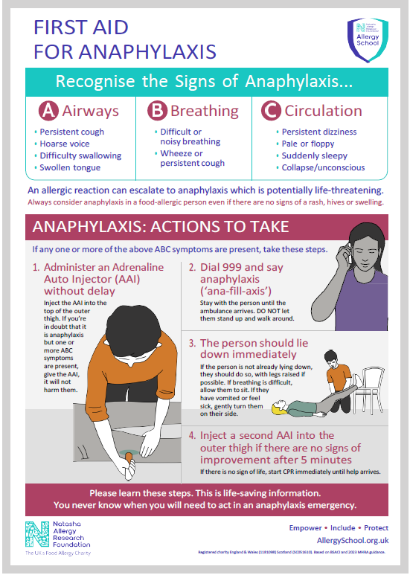

Appendix II - Epipen AAI and Jext AAI Instructions
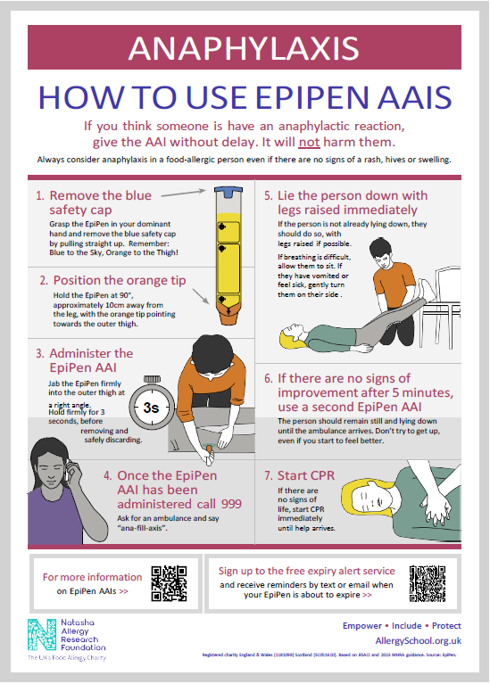

Appendix II - Epipen AAI and Jext AAI Instructions
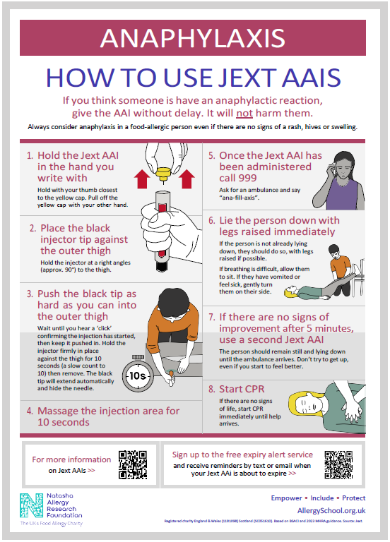

Appendix III - Flowchart for Allergic Reaction without use of Adrenaline Auto-Injector

Refer to the child’s BSACI Allergy Action Plan if they have one and call for other staff help if needed.

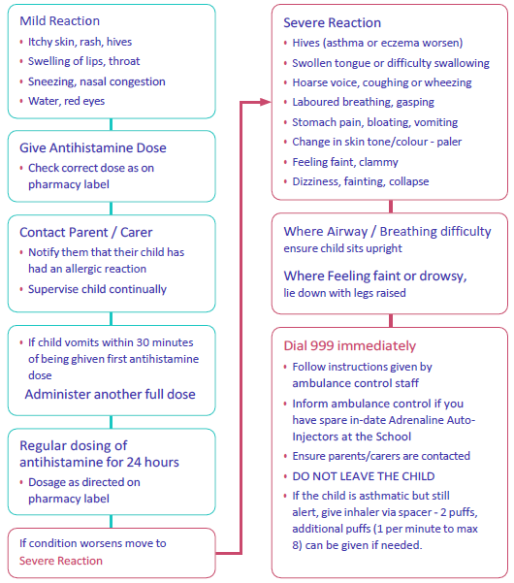

Appendix IV - Flowchart for Allergic Reaction with use of Adrenaline Auto-Injector

Refer to the child’s BSACI Allergy Action Plan if they have one and call for other staff help if needed.

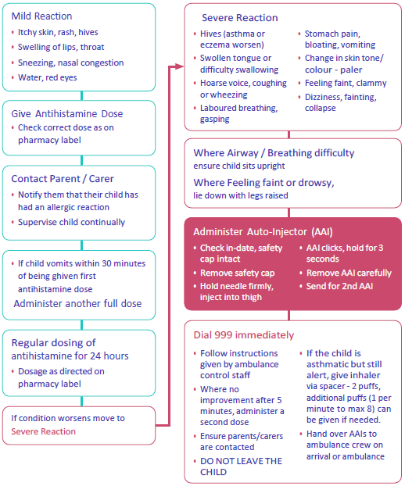

Appendix V - Information on allergies

The most common causes of food allergies relevant to this Policy are the fourteen food allergens:
• Cereals containing Gluten
• Celery
• Crustaceans
• Eggs
• Fish
• Soya
• Milk
• Nuts
• Peanuts
• Mustard
• Sesame Seeds
• Sulphur dioxide/Sulphites
• Lupin
• Molluscs

However, it is possible that any food has the potential to cause an allergic reaction. Contact with any food or materials containing a child’s allergen has the potential to cause an allergic reaction for that child.
Latex, chemicals, medicines, grasses, pollen, weeds, trees, pets, insect venom and animal dander (shedded flakes of skin) can also cause allergic reactions.

Symptoms

Mild to moderate symptoms include:
• Swelling of the eyes, face and lips
• Runny or congested nose
• Raised itchy rash (hives), eczema flare, skin flushing
• Itchy mouth
• Stomach cramps, nausea, vomiting, diarrhoea

Severe symptoms include:
• Swollen tongue, hoarse voice or cry, difficulty swallowing and talking
• Chest tightness
• Breathing difficulties, persistent cough, wheeze
• Low blood pressure, feeling faint, collapse
• Pale and floppy (babies and small children)

Appendix VI - Other support and resources

• Allergy Guidance for Schools - https://www.gov.uk/government/publications/school-food-standards-resources-for-schools/allergy-guidance-for-schools
• Allergy UK Helpline: providing support, advice and information for those living with allergic disease tel. weekdays 9am-5pm 01322 619898 - www.allergyuk.org
• Early Years Foundation Stage Statutory Guidance, Section 3 Safeguarding and Welfare Requirements - Food and Drink - Statutory framework for the early years foundation stage publishing.service.gov.uk
• Example menus for early years settings in England - Part I Guidance - Example menus for early years settings in England: part 1(publishing.service.gov.uk - Managing food allergies, intolerances and meeting cultural needs; Providing food allergen information; Reading food labels; Allergen information
• Food Standards Agency food allergy and intolerance online training - https://allergytraining.food.gov.uk/
• For pupils / students with Medical Conditions at School - Supporting pupils with medical conditions at school - GOV.UK (www.gov.uk)
Wales: https://www.gov.wales/sites/default/files/publications/2018-12/supporting-learners-with-healthcare-needs.pdf
Scotland: https://www.gov.scot/publications/supporting-children-young-people-healthcare-needs-schools/
Northern Ireland: https://www.education-ni.gov.uk/publications/supporting-pupils-medication-needs
• FSA reporting tool for allergies - https://www.gov.uk/government/news/fsa-launches-allergy-and-intolerance-reporting-tool
• Guidance on the use of adrenaline auto-injectors in schools (Department of Health, 2017) https://assets.publishing.service.gov.uk/government/uploads/system/uploads/attachment_data/file/645476/Adrenaline_auto_injectors_in_schools.pdf
Wales: https://www.gov.wales/sites/default/files/publications/2018-12/guidance-on-the-use-of-emergency-adrenaline-auto-injectors-in-schools-in-wales.pdf
• Training for Schools - https://www.anaphylaxis.org.uk/information-training/allergywise-training/for-schools/
• Transitioning to Secondary School - https://www.anaphylaxis.org.uk/living-with-serious-allergies/serious-allergy-guidance-for-parents/preparing-for-and-managing-the-transition-to-secondary-school/
• Whole school allergy and awareness management - https://www.allergyuk.org/schools/whole-school-allergy-awareness-andmanagement

Appendix VII - Top 14 Allergens poster



