Special Educational Needs and Disabilities (SEND) Information Report
Selsted CE Primary School


Inclusion Team
SEND Governor:
Matthew Stanley
SENDCO:
Hannah Hills
Contact No. 01303 844286
hhills@selsted.kent.sch.uk

Approved by: | Andrea Cooper (Interim Head Teacher) | Date:
Last reviewed on: | September 2026
Next review due by: | September 2027

Contents
1. What types of SEND does the school provide for? 4
2. Which staff will support my child? 5
3. What should I do if I think my child has SEND? 7
4. What happens if the school identifies a need? 8
5. How will the school measure my child’s progress? 9
6. How will I be involved in decisions made about my child’s education? 10
7. How will my child be involved in decisions made about their education? 11
8. How will the school adapt its teaching for my child? 12
9. How will the school evaluate whether the support in place is helping my child? 13
10. How will the school ensure my child has appropriate resources? 13
11. How will the school make sure my child is included in activities alongside pupils who don’t have SEND? 14
12. How does the school make sure the admissions process is fair for pupils with SEN or a disability? 15
13. How does the school support pupils with disabilities? 15
14. How will the school support my child’s mental health and emotional and social development? 16
15. What support is in place for looked-after and previously looked-after children with SEN? 16
16. What support will be available for my child as they transition between classes or settings or in preparing for adulthood? 17
17. What support is available for me and my family? (Local Offer) 18
18. What should I do if I have a complaint about my child’s SEND support? 19
19. Supporting Documents……………………………………………………………………………………………………….19
20. Glossary 20

Dear Parents and Carers,
The aim of this Information Report is to explain how we implement our SEND policy. In other words, we want to show you how SEND support works in our school.
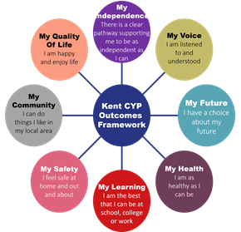
As educational professionals, we are all working towards the ultimate goal of growing independent young people as they prepare for adulthood. All provision and support we provide is working towards achieving the Kent Children and Young People (CYP) Outcomes Framework:

If you want to know more about our arrangements for SEND, read our SEND policy alongside this Information Report.
You can find our SEND policy on our website: https://www.selstedschool.org/policies-2/

Note: If there are any terms we’ve used in this information report that you’re unsure of, you can look them up in the Glossary at the end of the report.

1. What types of SEND does the school provide for?

Our school provides for pupils with the following needs (as outlined in the SEND Code of Practice 2015):

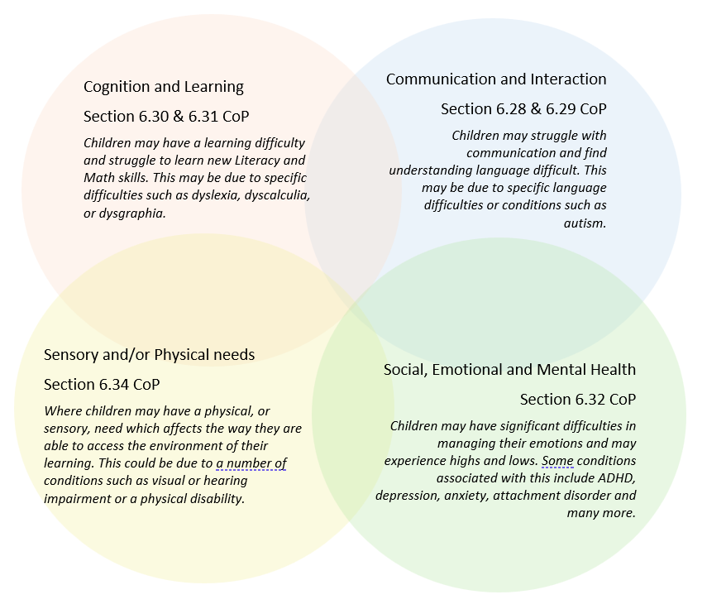
Often, children’s needs overlap and are rarely confined to one area, which is why it is important to gain a holistic overview of your child.
More information about the Areas of Need can be found in the Special Educational Needs and disability code of Practice: 0 to 25 years (link below).
SEND_Code_of_Practice_January_2015.pdf (publishing.service.gov.uk)


2. Which staff will support my child, and what are their key responsibilities?

At Selsted CE Primary School, all staff are responsible for supporting the needs of pupils with SEND. Our staff are committed to ongoing, high-quality training to ensure they have the knowledge and skills to better meet a wide range of pupil needs.
The following outlines the key staff who will be supporting your child. Please note that this list is not exhaustive.
Our Special Educational Needs Co-ordinator, or SENCO
Our SENCO is Hannah Hills.
She has been in this role for one year and is a qualified teacher who has been at Selsted CE Primary since 2018.
She is working towards her National Award in Special Educational Needs Co-ordination, which she will complete in 2027.

Class/subject teachers
All our teachers receive in-house SEN training and are supported by the SENCO to meet the needs of pupils with SEN.
Staff have also received training from the Specialist Teaching and Learning Service and the Speech and Language team.

Teaching assistants (TAs)
We have a small team of TAs and one higher-level teaching assistant (HLTA) trained to deliver SEN provision.
We have teaching assistants trained to deliver interventions such as Toe by Toe, Clever Hands, Sensory Circuits, Little Wandle Catch Up, Beat Dyslexia, Speech and Language, and others. One of our TAs also delivers an outdoor learning intervention that reaches more than 20 children each week, building their resilience, self-confidence, and independence.

External agencies
Sometimes we need extra help to offer our pupils the support that they need. Whenever necessary, we will work with external support services to meet the needs of our pupils with SEND and to support their families. These may include:
- NHS Speech and Language (Annie Finney, link therapist)
- Educational Psychologist (Fiona Wallis, link EP - 3x yearly school-based reviews)
- Occupational Health
- School Nurse
- STLS (Becky Rose, link therapist)
- Physiotherapy
- Paediatricians
- Family Help Team
- SEN Assessment team
- Community of Schools meetings (funding approval, training, and professional conversations around children/school support)
- Salus Group (supporting a pupil in school with SEMH needs)
- Kent Family Hub

3. What should I do if I think my child has SEND?

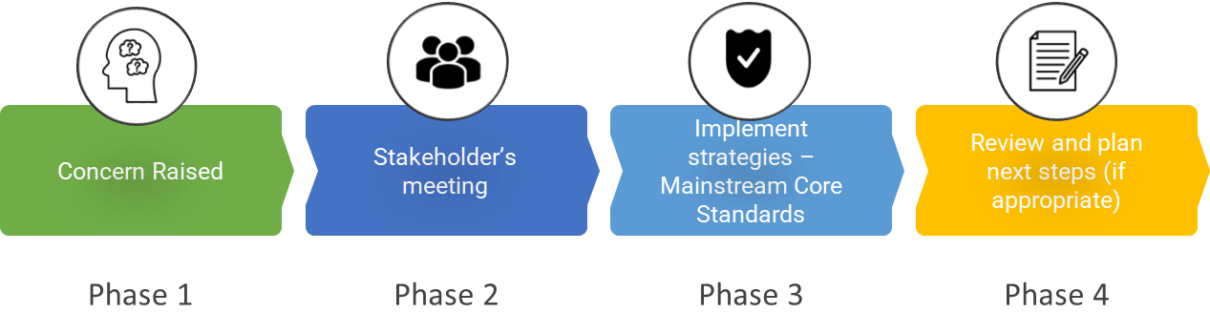

Phase 1 | In the first instance, please raise this with your child's class teacher at parents' evening or at any other time. You can also contact the school office on 01303 844286 to arrange a phone call or meeting with Hannah Hills, our SENDCO.
Phase 2 | The appropriate adults will meet with you to discuss your concerns and try to get a better understanding of what your child’s strengths and difficulties are. Together we will decide what outcomes to seek for your child and agree on next steps. We will make a note of what’s been discussed and add this to your child’s record.
Phase 3 | We will implement the agreed strategies and monitor these over an agreed period of time. These are likely to be universal strategies set out in the mainstream core standards. A copy of this can be found here: https://www.kelsi.org.uk/__data/assets/pdf_file/0005/117257/Special-educational-needs-mainstream-core-standards-guide-for-parents.pdf . This will initiate the ‘Graduated Approach’ where support will be continually reviewed. See next page for more details.
Phase 4 | If we decide that your child needs SEND support, we will formally notify you, and your child will be added to the school’s SEND register. They will receive additional support, and this will be reviewed using the assess, plan, do, review model.

4. What happens if the school identifies a need?
The same process is followed if a concern is raised by the school.

All our class teachers are responsible for monitoring all pupils who have been identified as having SEND. They also review those who are not making the expected level of progress in their schoolwork or socially. This might include reading, writing, understanding numbers, and interaction and communication with adults and peers.
If the teacher notices that a pupil is having difficulties, they try to determine whether the pupil has any gaps in their learning. If they identify a gap, the school will provide appropriate support. Pupils who don’t have SEND usually make progress quickly once the gap in their learning has been filled.
If the pupil is still finding it difficult to make the expected progress, the teacher will talk to the SENDCO and will contact you to discuss the possibility that your child has SEND, and the school will follow the graduated approach (see previous page).

5. How will the school measure my child’s progress?

We will follow the ‘graduated approach’ to meeting your child’s SEND needs.
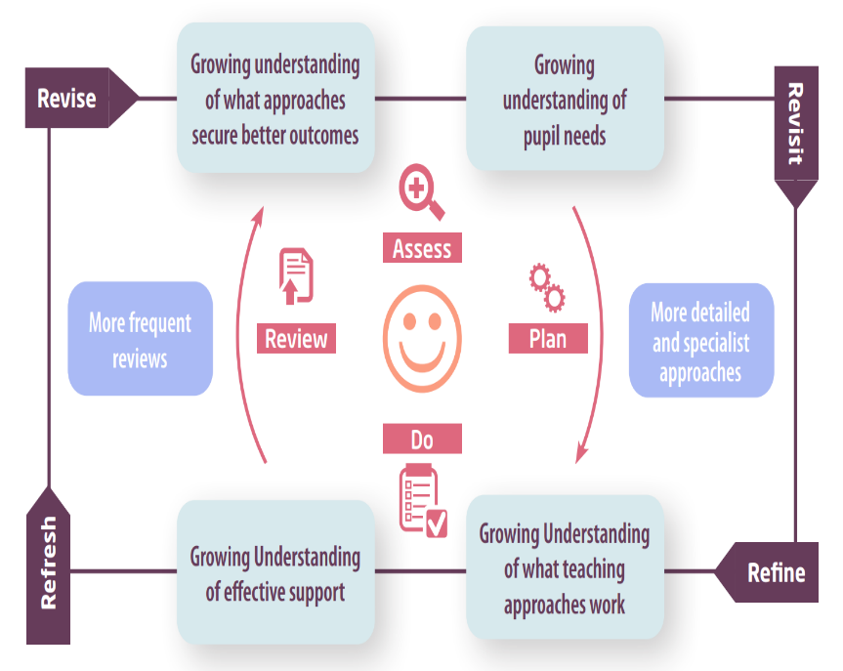
The graduated approach is a 4-part cycle of assess, plan, do, review.

Assess | If your child is not making the expected level of progress, we will make an assessment to find out what strengths and difficulties your child has. We will ask for you and your child’s input, as well as getting help from external professionals where necessary.
Plan | In discussion with you and your child, we will decide what outcomes we are hoping to achieve. We will plan the support we will offer your child to help them meet those outcomes. We will make a record of this and share it with you and all relevant school staff.
Do | We will put our plan into practice.  The class teacher, with the support of the SENDCO, will work with your child daily and ensure the support we put in place has the impact we intended.
Review | We will assess how well the support we put in place helped the pupil to meet the outcomes we set. We will use our improved understanding of your child’s needs to improve the support we offer; this may mean the Plan, Assess, Do, Review cycle continues.

6. How will I be involved in decisions made about my child’s education?
We will provide reports on your child's progress at least three times a year, in addition to our regular parent-teacher conferences.
A member of staff who knows your child well will meet you at least twice a year (at parents' evenings), to:
- Set clear outcomes for your child’s progress
- Review progress towards those outcomes
- Discuss the support we will put in place to help your child make that progress
- Identify what we will do, what we will ask you to do, and what we will ask your child to do

The SENDCO may also attend these meetings to provide extra support.
We know that you’re the expert when it comes to your child’s needs and aspirations. So, we want to make sure you have a full understanding of how we’re trying to meet your child’s needs, so you can provide insight into what you think would work best for your child.
We also want to hear from you as much as possible so that we can build a clearer picture of how the SEND support we provide is affecting your child outside of school.
If your child’s needs or aspirations change at any time, please let us know right away so we can keep our provision as relevant as possible.
If concerns arise between these meetings, please contact the school office on 01303 844286, and they will put you in touch with your child's class teacher or Hannah Hills, our SENDCO.

7. How will my child be involved in decisions made about their education?

The level of involvement will depend on your child’s age and individual needs. We recognise that no two pupils are the same, so we will decide on a case-by-case basis, with your input.
We may seek your child’s views by asking them to:
- Attend meetings to discuss their progress and outcomes
- Prepare a presentation, written statement, video, drawing, etc.
- Discuss their views with a member of staff who can act as a representative during the meeting
- Complete a survey



8. How will the school adapt its teaching for my child?
Our Accessibility Plan is available at https://www.selstedschool.org/policies-2/ and outlines how we determine the extent to which disabled pupils can participate in the curriculum alongside their peers.
Your child's teacher is responsible and accountable for the progress and development of all the pupils in their class.
High-quality teaching is our first step in responding to your child’s needs. We will make sure that your child has access to a broad and balanced curriculum in every year they are at our school.
We will adapt our teaching approaches to suit how the pupil works best. There is no 'one size fits all’ approach to adapting the curriculum; we work on a case-by-case basis to make sure the adaptations we make are meaningful to your child and are guided by the Mainstream Core Standards in the first instance.

These adaptations may include:
- Adapting our approaches, for example, giving longer processing times, pre-teaching of key vocabulary, reading instructions aloud, etc.

- Adapting our resources and staffing

- Using recommended aids, such as laptops, coloured overlays, visual timetables, larger font, etc.

- Teaching assistants or support staff will support pupils appropriately depending on their presentation of need

- Scaffolding lesson materials

We may also provide the following interventions:
Beat Dyslexia for pupils identified with dyslexia, Toe By Toe, Little Wandle Catch Up, Outdoor Learning, TA-delivered speech and language interventions, Sensory Circuits, and SEND trolleys accessible to children in both KS1 and KS2 (fidget toys, ear defenders, wobble cushions, handwriting grips, sensory relief toys).

These interventions are part of our contribution to Kent County Council’s local offer.

9. How will the school evaluate whether the support in place is helping my child?

We will evaluate the effectiveness of provision for your child by:
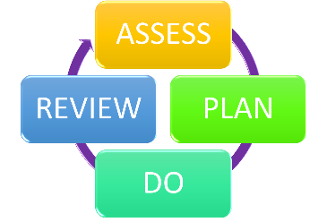
- Reviewing their progress towards their goals each term
- Reviewing the impact of interventions on an agreed, regular basis
- Using pupil questionnaires
- Monitoring by the SENCO
- Using provision maps to measure progress
- Holding an annual review (if they have an education, health and care (EHC) plan)

10. How will the school ensure my child has appropriate resources?

It may be that your child’s needs mean we need to provide additional resources such as:
- Additional resources to support their learning
- Adaptations to in class support
- Further training for our staff
- External specialist expertise
Where appropriate, we will consult with external agencies to obtain recommendations on what will best help your child access their learning, and we will use our best efforts to ensure these are provided.
We do not currently have any pupils in school accessing high needs funding. Where additional funding is required, we access it through the Community of Schools model and the Inclusive Mainstream Fund.

11. How will the school make sure my child is included in activities alongside pupils who don’t have SEND?


The expectation is that all schools provide an inclusive provision for all pupils. It may be necessary for some pupils to receive interventions in addition to a broad and balanced curriculum.
All our extra-curricular activities and school visits are available to all pupils, including our before- and after-school clubs.
All pupils are encouraged to attend our school trips, sporting events, and residential visits.
All pupils are encouraged to take part in sports day, school plays and other whole-school events.
No pupil is ever excluded from taking part in these activities because of their SEN or disability, and we will make whatever reasonable adjustments are needed to make sure that they can be included.
We have an outdoor learning provision, accessed by over 20 children each week, with every child in the school experiencing Forest School provision at least once every 2 terms.

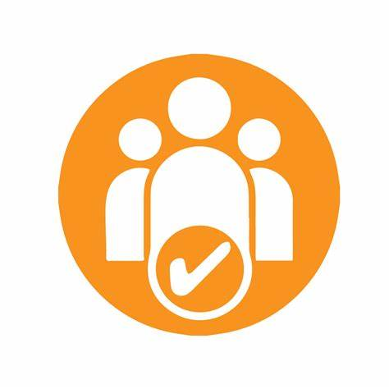
12. How does the school make sure the admissions process is fair for pupils with SEN or a disability?

As a Voluntary Controlled school, we follow Kent County Council's coordinated admissions scheme. Each year, we admit 15 pupils to Reception. Applications are made using the Common Application Form, either collected from the school office or completed online. Applications are sent to the Local Authority, which allocates places according to the admissions criteria below.
Where the number of applicants exceeds the number of places available, priority is given in the following order:
- Children in Local Authority Care (Looked after children). Looked-after children refers to children in public care. This includes adopted children.

- Current family association. Where a brother or sister is in the same school at the time of entry and lives at the same address as when the sibling was admitted, or is within 2 miles of the school.

- Health and special access reasons. A child who, due to health or physical impairment, needs to attend a particular school. Evidence needs to be supported in writing by a medical practitioner.

- Nearness of child's home and ease of access to school. KCC measures distances in a straight line using software that uses a defined point within the child's home and a defined point within the school, as specified by the Ordnance Survey. KCC will advise parents of the school allocated to them. If parents are declined a place, they have the right to appeal against a decision to the LEA if they wish. This will then go to a School Admission Appeal panel.

Children with an Education, Health and Care (EHC) Plan naming Selsted will be allocated a place by Kent County Council's Admissions department before general allocation.
Oversubscription: A waiting list will be kept for applicants refused admission due to oversubscription whose parents or carers make a written request to have their child's name placed on the waiting list. The list will be kept in the sequence of the criteria described above and re-ranked, in line with the published oversubscription criteria, every time a child is added. As and when places become available, they will be offered to applicants. Names will be kept alongside any additional names throughout the year on the waiting list until the end of the academic year for which the application for admission was made.
Admissions to Year Groups other than Reception
These can occur at any time of the year and are referred to as 'In Year Admissions'. To apply, you will need to complete an In Year Admission Form (IYAF), which can be obtained from the School Office. If a place is available, we will inform you and write to offer the school place. This place must be accepted or declined within 10 days. If a place is not available, you will be notified in writing and added to the waiting list according to the priority criteria stated above.

13. How does the school support pupils with disabilities?


- The steps you have taken to prevent disabled pupils from being treated less favourably than other pupils
See Accessibility Plan for more information.
You’re disabled under the Equality Act 2010 if you have a physical or mental impairment that has a ‘substantial’ and ‘long-term’ negative effect on your ability to do normal daily activities.

14. How will the school support my child’s mental health and emotional and social development?
We provide support for pupils to progress in their emotional and social development in the following ways:
- Pupils with SEND are encouraged to be part of the school council
- Pupils with SEND are also encouraged to be part of our extra-curricular clubs to promote teamwork and build friendships
- We provide extra pastoral support for listening to the views of pupils with SEND, including regular check-ins
- We have achieved our Nurture UK status, and run sensory circuits each morning to give children a soft landing into the school day
- We have a 'zero tolerance' approach to bullying.

15. What support is in place for looked-after and previously looked-after children with SEND?


Andrea Cooper, Designated Teacher for looked-after children, will work with Hannah Hills, our SENCO, to ensure all teachers understand how a looked-after or previously looked-after pupil's circumstances and SEND might interact, and what the implications are for teaching and learning.
Pupils who are looked-after or previously looked-after will be supported much in the same way as any other child who has SEND. However, looked-after pupils will also have a Personal Education Plan (PEP). We will make sure that the PEP and any SEND support plans or EHC plans are consistent and complement one another.

16. What support will be available for my child as they transition between classes or settings or in preparing for adulthood?
Between years

To help pupils with SEND be prepared for a new school year we:
- Ask both the current teacher and the next year's teacher to attend a meeting with parents and SENCO where the pupil's SEND is discussed (Term 6)
- Have a full week of transition in the new class at the end of Term 6
- Prepare a transition booklet of the new classroom and adults
Between schools
When your child is moving on from our school, we will ask you and your child what information you want us to share with the new setting.
Between phases
The SENCO of the secondary school will come to our school for a meeting with our SENCO and the children joining them. They will discuss the needs of all the pupils who are receiving SEND support.

Pupils will be prepared for the transition by:
- Learning how to get organised independently
- Plugging any gaps in their knowledge
- Meeting staff from the secondary school in a familiar environment
- Transition events organised by FESI(local collaboration)
- If needed, extra transition sessions can be arranged with some secondary schools.
Joining us
Our local authority provides an early years advisory teacher to support children with SEND as they transition to our Reception class from pre-school settings. Transition into Reception is supported by meetings, meet-the-teacher sessions and taster sessions in the new class.
We will plan a child's transition to us using information from parents and all professionals already involved in supporting the child to help ensure a smooth and supportive start.

17. What support is available for me and my family?
If you have questions about SEND or are struggling to cope, please get in touch to let us know. We want to support you, your child, and your family.
To see what support is available to you locally, have a look at Kent County Council's local offer: https://www.kent.gov.uk/education-and-children/special-educational-needs
Our local special educational needs and disabilities information, advice and support services (SENDIASS) organisation is:
Information Advice and Support Kent - https://www.iask.org.uk/
Local charities that offer information and support to families of pupils with SEND are:
IncludeUs2 - www.includeus2.org.uk
Talking Walk-ins - https://www.ekhuft.nhs.uk/services/talking-walk-ins/
Dandelion Time - https://dandeliontime.org.uk/
Kent Autistic Trust - https://www.kentautistictrust.org/
Homestart - https://www.homestartshepway.org.uk/
Live Well Kent and Medway - https://livewellkent.org.uk/in-your-area/
Kent Family Hub - https://local.kent.gov.uk/kb5/kent/directory/service.page?id=0Uc_cR8lBBU
We work with other charities as well. Please speak to our SENCO for more information.
National charities that offer information and support to families of pupils with SEND are:
- IPSEA
- SEND family support
- NSPCC
- Family Action
- Special Needs Jungle

18. What should I do if I have a complaint about my child’s SEND support?
Complaints about SEND provision in our school should be made to the Head Teacher in the first instance. We encourage parents to discuss their concerns so we can resolve the issue before making a formal complaint to the Chair of the Governing Body.
If the complaint is not resolved after it has been considered by the Governing Body, a disagreement resolution service or mediation service can be contracted. If it remains unresolved after this, the complainant can appeal to the First-tier Tribunal (Special Educational Needs and Disability), if the case refers to disability discrimination, or to the Secretary of State for all other cases.
To see a full explanation of suitable avenues for complaint, see pages 246 and 247 of the SEND Code of Practice.
If you feel that our school discriminated against your child because of their SEND, you have the right to make a discrimination claim to the first-tier SEND tribunal. To find out how to make such a claim, you should visit: https://www.gov.uk/complain-about-school/disability-discrimination
You can make a claim about alleged discrimination regarding:
- Admission
- Exclusion
- Provision of education and associated services
- Making reasonable adjustments, including the provision of auxiliary aids and services
Before going to a SEND tribunal, you can go through processes called disagreement resolution or mediation, where you try to resolve your disagreement before it reaches the tribunal. Kent County Council uses Global Mediation and Disagreement Resolution. The Kent County Council caseworker overseeing your case will be able to advise on how to access this service if it is appropriate.

19. Supporting documents

- Equality Information and Objectives Policy
- Child protection and safeguarding policy
- Behaviour Policy
- Accessibility Plan
- Attendance and punctuality policy
- SEND policy
- SEN & Disabilities Code Of Practice 2015
- Mainstream Core Standards

20. Glossary
- Access arrangements – special arrangements to allow pupils with SEND to access assessments or exams
- Annual review – an annual meeting to review the provision in a pupil’s EHC plan
- Area of need – the 4 areas of need describe different types of needs a pupil with SEND can have. The 4 areas are communication and interaction; cognition and learning; physical and/or sensory; and social, emotional and mental health needs.
- CAMHS – child and adolescent mental health services
- Differentiation – when teachers adapt how they teach in response to a pupil’s needs
- EHC needs assessment – the needs assessment is the first step on the way to securing an EHC plan. The local authority will do an assessment to decide whether a child needs an EHC plan.
- EHC plan – an education, health and care plan is a legally-binding document that sets out a child’s needs and the provision that will be put in place to meet their needs.
- First-tier tribunal/SEND tribunal – a court where you can appeal against the local authority’s decisions about EHC needs assessments or plans and against discrimination by a school or local authority due to SEND
- Graduated approach – an approach to providing SEND support in which the school provides support in successive cycles of assessing the pupil’s needs, planning the provision, implementing the plan, and reviewing the impact of the action on the pupil
- Intervention – a short-term, targeted approach to teaching a pupil with a specific outcome in mind
- Local offer – information provided by the local authority which explains what services and support are on offer for pupils with SEND in the local area
- Outcome – target for improvement for pupils with SEND. These targets don't necessarily have to be related to academic attainment
- Reasonable adjustments – changes that the school must make to remove or reduce any disadvantages caused by a child’s disability
- SENCO – the special educational needs co-ordinator
- SEN – special educational needs
- SEND – special educational needs and disabilities
- SEND Code of Practice – the statutory guidance that schools must follow to support pupils with SEND
- SEND information report – a report that schools must publish on their website, that explains how the school supports pupils with SEND
- SEND support – special educational provision which meets the needs of pupils with SEND
- Transition – when a pupil moves between years, phases, schools or institutions or life stages

