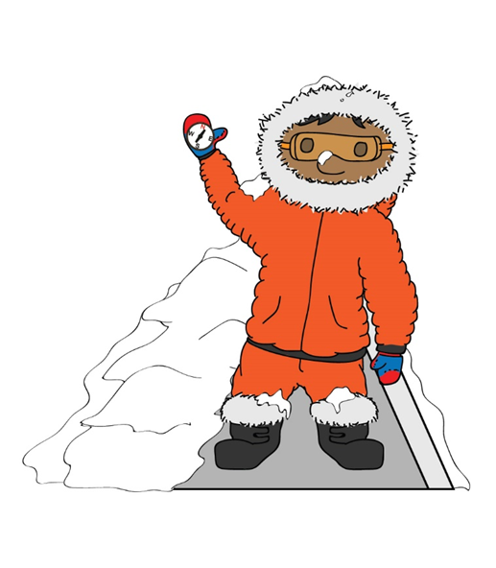
Our PE units this term will be basketball and OAA- Outdoor Adventurous Activities. In basketball, the children will get a chance to experience and try out more advanced techniques and games, building on what they experienced last year. In our OAA session, we are very keen to develop our teamwork and problem-solving skills, by
engaging in our new school programme, which involves us navigating the school grounds to find clues and answer questions relating to different aspects of our curriculum.
Maths
ime – Time Zones Maths Games
This term, both year groups will be looking at place value. Year 1 children will be thinking about comparing, sorting and grouping objects, before doing the same with our numbers to 20. We will learn how to find 1 more and less before being able to confidently count forwards and backwards to 20.
Year 2 children will be recapping their numbers up to 100, determining how many tens and ones are needed to make a particular number. Children will then learn how to count forwards/ backwards in 10s, 5s and 2s, before moving onto counting in 3s.
This term in English, we will be introduced to different types of writing genres. These will be revisited throughout the year, where we will build upon the knowledge gained this term. From starting our year by learning about recounts to share our summer holiday experiences, we will also progress onto learning about instructions, fact files, story writing, letters and poetry. These writing genres will be linked where possible to our topic and different texts, such as ‘Aliens Love Underpants’.
PE

English
“Inter-Nation Media Station” is a thematic unit, based on media and broadcasting, with a key focus on history, through which pupils will learn about early methods of communication, leading to the invention of both the television and radio. Pupils will develop confidence in oracy, through opportunities to work on their own broadcasts.

Theme Overview
RE
In RE this term, our big question related to ‘Creation’ is: “Who made the World?” We will be retelling The Creation Story and understanding how Creation is the beginning of the ‘big story’ in the Bible. We will be learning what the story tells Christians about what God is like, before thinking about how Christians thank God for his creation. Additionally, we will be thinking about what we are thankful for in our amazing World.

Science
History
This term in science, our learning will be focused on seasonal changes.
Whilst we learn about the sharing of news and the media in other subjects, we will link this back to the reporting of weather forecasts. We will begin to observe weather changes across our seasons, particularly noting the changes in weather between summer and autumn and we will describe what we notice. To help us with this, we will film our very own short weather forecasts!
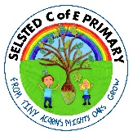
Throughout this term, we will be looking at different historical elements. We will be thinking about technological advances in communication, recognising how our different ways of communication has developed over time.
We will also be looking at how familiar technology has evolved, for example, learning how phones used to be landline phones, in comparison to today’s mobile phones and how televisions used to be black and white with very few channels.


In Art this topic, we will be looking at digital imagery through media. The children will be using iPads to take pictures and then change them from coloured images to black and white images.
The children will also be looking at the work of Theresa Elvin and how she uses black and white images with blocks of colour for effect.
Art

In music this term, we will be exploring different musical instruments to represent the different types of weather we have. We will also be thinking about making our own jingle to accompany a new cereal advertisement and learning some songs for our Harvest celebrations.
Music

This term, our unit: Inter- Nation Media Station is heavily linked to different aspects of computing. We will therefore be doing lots of cross curricular computing, such as when filming our weather forecasts or changing our art work to black and white images, etc.
Computing

